**Syntax error uncaught token exception ‘<’**

tsconfig.json

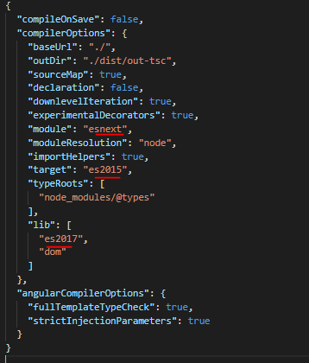

Index.html

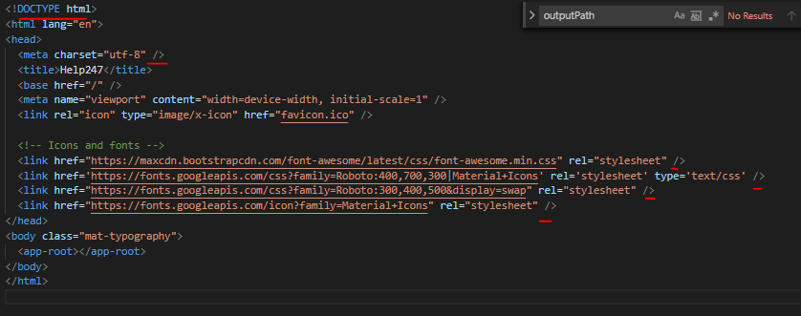

Startup

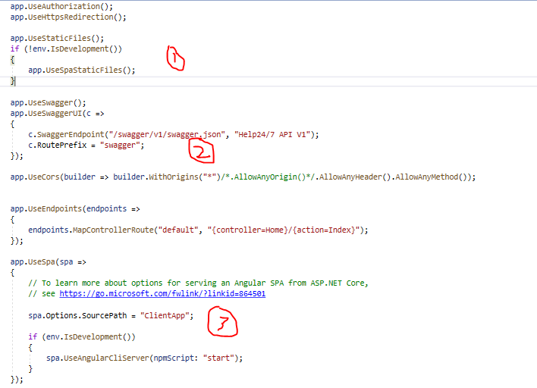

Project.csproj

<PropertyGroup>

<TargetFramework>netcoreapp3.1</TargetFramework>

<AspNetCoreHostingModel>outofprocess</AspNetCoreHostingModel>

<TypeScriptCompileBlocked>true</TypeScriptCompileBlocked>

<TypeScriptToolsVersion>Latest</TypeScriptToolsVersion>

<IsPackable>false</IsPackable>

<SpaRoot>ClientApp\</SpaRoot>

<DefaultItemExcludes>$(DefaultItemExcludes);$(SpaRoot)node_modules\**</DefaultItemExcludes>

<!-- Set this to true if you enable server-side prerendering -->

<BuildServerSideRenderer>false</BuildServerSideRenderer>

</PropertyGroup>

<ItemGroup>

<!-- Don't publish the SPA source files, but do show them in the project files list -->

<Content Remove="$(SpaRoot)**" />

<None Remove="$(SpaRoot)**" />

<None Include="$(SpaRoot)**" Exclude="$(SpaRoot)node_modules\**" />

</ItemGroup>

<Target Name="DebugEnsureNodeEnv" BeforeTargets="Build" Condition=" '$(Configuration)' == 'Debug' And !Exists('$(SpaRoot)node_modules') ">

<!-- Ensure Node.js is installed -->

<Exec Command="node --version" ContinueOnError="true">

<Output TaskParameter="ExitCode" PropertyName="ErrorCode" />

</Exec>

<Error Condition="'$(ErrorCode)' != '0'" Text="Node.js is required to build and run this project. To continue, please install Node.js from https://nodejs.org/, and then restart your command prompt or IDE." />

<Message Importance="high" Text="Restoring dependencies using 'npm'. This may take several minutes..." />

<Exec WorkingDirectory="$(SpaRoot)" Command="npm install" />

</Target>

<Target Name="PublishRunWebpack" AfterTargets="ComputeFilesToPublish">

<!-- As part of publishing, ensure the JS resources are freshly built in production mode -->

<Exec WorkingDirectory="$(SpaRoot)" Command="npm install" />

<Exec WorkingDirectory="$(SpaRoot)" Command="npm run build -- --prod" />

<Exec WorkingDirectory="$(SpaRoot)" Command="npm run build:ssr -- --prod" Condition=" '$(BuildServerSideRenderer)' == 'true' " />

<!-- Include the newly-built files in the publish output -->

<ItemGroup>

<DistFiles Include="$(SpaRoot)dist\**; $(SpaRoot)dist-server\**" />

<DistFiles Include="$(SpaRoot)node_modules\**" Condition="'$(BuildServerSideRenderer)' == 'true'" />

<ResolvedFileToPublish Include="@(DistFiles->'%(FullPath)')" Exclude="@(ResolvedFileToPublish)">

<RelativePath>%(DistFiles.Identity)</RelativePath>

<CopyToPublishDirectory>PreserveNewest</CopyToPublishDirectory>

<ExcludeFromSingleFile>true</ExcludeFromSingleFile>

</ResolvedFileToPublish>

</ItemGroup>

</Target>